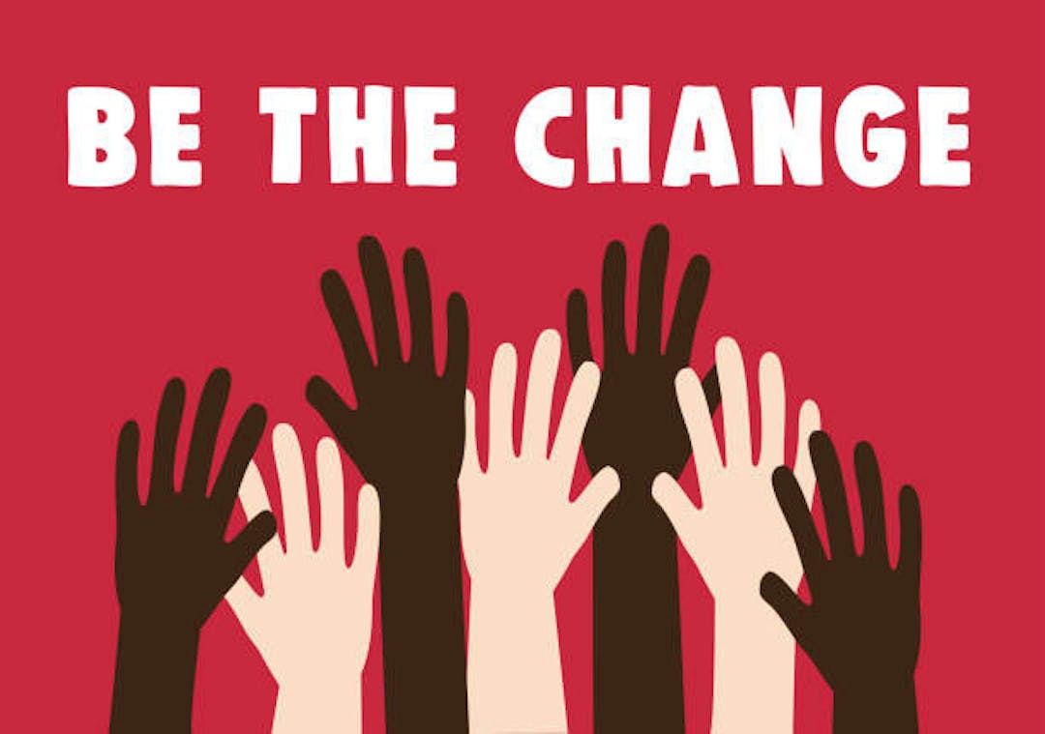**Racial injustice is a major and pervasive problem that affects people and communities of all races and ethnicities in many regions of the world. People are treated unfairly and unequally depending on their race or ethnicity under this sort of injustice. It manifests in a variety of ways, including unconscious bias, microaggressions, and systematic racism and discrimination.**

**Indigenous people's marginalization and discrimination is one of the most notable instances of racial injustice. These communities have experienced cultural genocide, land eviction, and forced assimilation into Western society. Many Indigenous communities still do not have access to basic necessities like clean water, healthcare, and education.**

**Discrimination against those of African origin is another type of racial injustice. Black people continue to face prejudice, racism, and discrimination in many nations and in several facets of life. This covers everything, from housing options and work prospects to healthcare and the legal system. The Black Lives Matter movement, which was born in the US in response to systematic racism and police brutality, has increased awareness of this problem and shown how important reform is.**

**A comprehensive and integrated strategy must be used to fight racial injustice. This entails understanding the intricate and intertwined relationships that exist between racism and other oppressions including gender, class, and sexuality.** **It also calls for a dedication to advancing social and economic justice for all while tearing down the institutions and frameworks that support racial inequality. In the end, the struggle against racial injustice is a global undertaking that calls for constant education, discussion, and action from people, communities, and governments all around the world.**

**References:** *Striving for Racial Equity*. (n.d.). https://www.guidinggolden.com/striving-for-racial-equity?tool=news_feed.